David Guijosa HTML Summer 2021 Assignment #4

**Part 1 Screenshot: Your “Groceries Table Page” displaying in the browser Screenshot**

[Paste your part 1 Groceries Table page screenshot below. The browser window surrounding the page should be visible. Use 2 screenshots if necessary to show the whole page.]

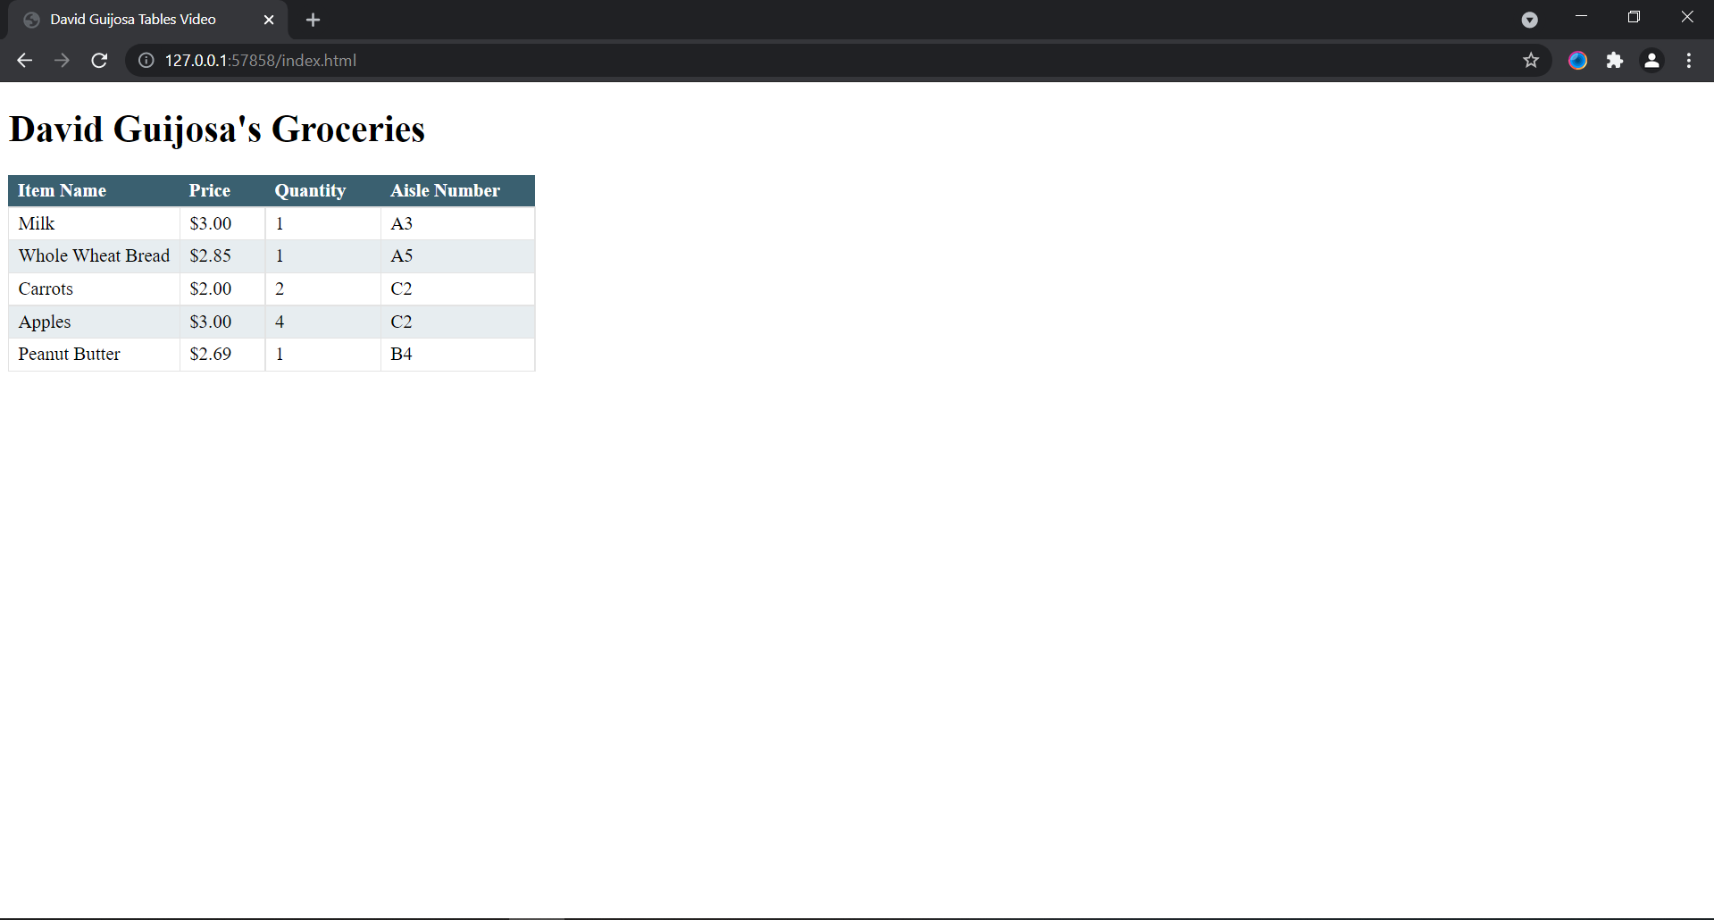

**Part 1 HTML Code: Your “index.html” Groceries Table page HTML Code**

[Paste your “index.html” HTML Code below – Be sure to paste ALL of the HTML code for the file. No screen shots here! Use “Courier New” or another monospace font to make your code more readable. Bold the code too if that helps make it more readable. ]

**<!DOCTYPE html>**

**<html lang="en">**

**<head>**

**<meta charset="utf-8">**

**<title>David Guijosa Tables Video</title>**

**<link rel="stylesheet" href="main.css">**

**</head>**

**<body>**

**<h1>David Guijosa's Groceries</h1>**

**<table>**

**<tr>**

**<th>Item Name</th>**

**<th>Price</th>**

**<th>Quantity</th>**

**<th>Aisle Number</th>**

**</tr>**

**<tr>**

**<td>Milk</td>**

**<td>$3.00</td>**

**<td>1</td>**

**<td>A3</td>**

**</tr>**

**<tr>**

**<td>Whole Wheat Bread</td>**

**<td>$2.85</td>**

**<td>1</td>**

**<td>A5</td>**

**</tr>**

**<tr>**

**<td>Carrots</td>**

**<td>$2.00</td>**

**<td>2</td>**

**<td>C2</td>**

**</tr>**

**<tr>**

**<td>Apples</td>**

**<td>$3.00</td>**

**<td>4</td>**

**<td>C2</td>**

**</tr>**

**<tr>**

**<td>Peanut Butter</td>**

**<td>$2.69</td>**

**<td>1</td>**

**<td>B4</td>**

**</tr>**

**</table>**

**</body>**

**</html>**

**Part 1 CSS Code: Your “main.css” Groceries Table page CSS Code**

[Paste your “main.css” CSS Code below – Be sure to paste ALL of the CSS code for the file. No screen shots here! Use “Courier New” or another monospace font to make your code more readable. Bold the code too if that helps make it more readable.]

**table{**

**border-collapse: collapse;**

**}**

**table th{**

**text-align: left;**

**background-color: #3a6070;**

**color: #FFF;**

**padding: 4px 30px 4px 8px;**

**}**

**table td{**

**border: 1px solid #e3e3e3;**

**padding: 4px 8px;**

**}**

**table tr:nth-child(odd) td{**

**background-color: #e7edf0;**

**}**

**Part 2 Screenshot: Your “Oceanside.html” page displaying in the browser.**

[Paste your part 2 Oceanside.html page browser screenshot below. Use 2 screenshots if necessary to show the entire page in the browser. The surrounding browser window should be visible in the screen shot.]

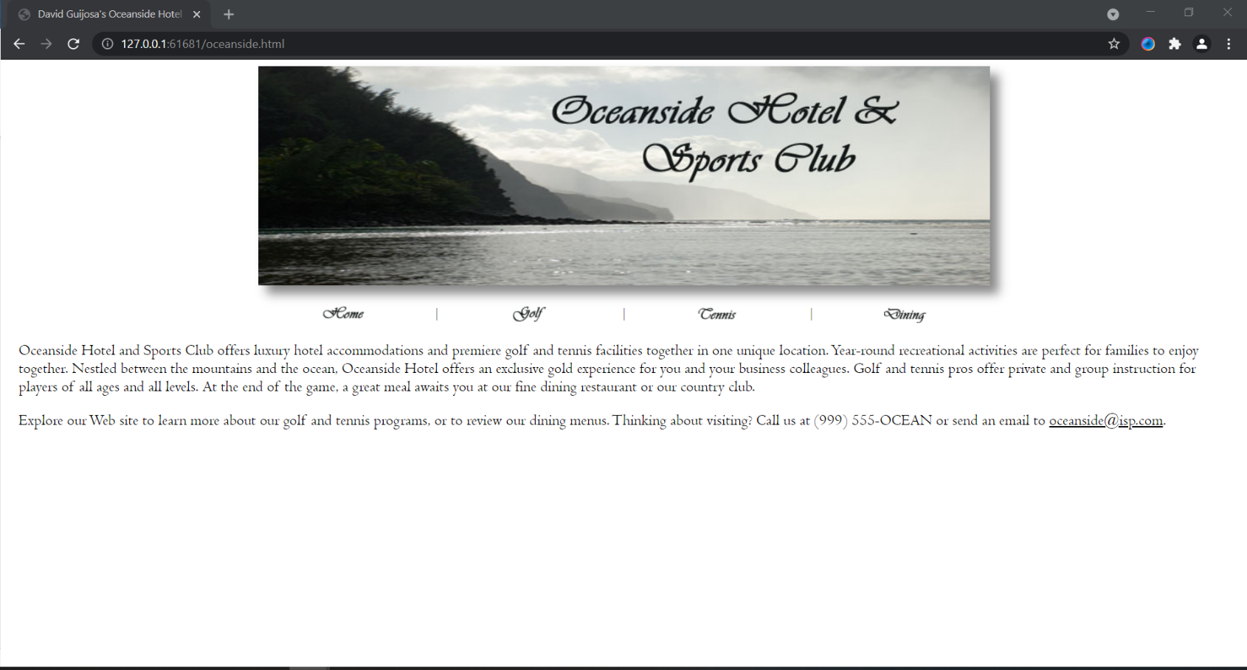

**Part 2 HTML Code #1: Your Oceanside.html HTML Code:**

[Paste your Oceanside.html page Code below – Be sure to paste ALL of the HTML code for the page. No screen shots here! Use “Courier New” or another monospace font to make your code more readable. Bold the code too if that helps make it more readable.]

**<html><head>**

**<meta charset="UTF-8">**

**<meta name="description" content=" David Guijosa's Oceanside Hotel and Sports Club">**

**<meta name="keywords" content="Hotel">**

**<meta name="author" content="David Guijosa">**

**<title>David Guijosa's Oceanside Hotel and Sports Club</title>**

**<link rel="stylesheet" type="text/css" href="stylesch4.css">**

**</head>**

**<body>**

**<div>**

**<img src="oceansidelogo.jpg" width="866" height="259" alt="Oceanside logo" style="box-shadow: 10px 10px 12px #888888">**

**</div>**

**<br>**

**<table class="menu" style="border-style: none">**

**<tbody>**

**<tr>**

**<td class="menuicon"><a href="oceanside.html"><img src="home.gif" width="50" height="21" alt="Home"></a></td>**

**<td class="menupipe">|</td>**

**<td class="menuicon"><a href="golf.html"><img src="golf.gif" width="50" height="21" alt="Golf"></a></td>**

**<td class="menupipe">|</td>**

**<td class="menuicon"><a href="tennis.html"><img src="tennis.gif" width="50" height="21" alt="Tennis"></a></td>**

**<td class="menupipe">|</td>**

**<td class="menuicon"><a href="dining.html"><img src="dining.gif" width="50" height="21" alt="Dining"></a></td>**

**</tr>**

**</tbody>**

**</table>**

**<p>Oceanside Hotel and Sports Club offers luxury hotel accommodations and premiere golf and tennis facilities together in one unique location. Year-round recreational activities are perfect for families to enjoy together. Nestled between the mountains and the ocean, Oceanside Hotel offers an exclusive gold experience for you and your business colleagues. Golf and tennis pros offer private and group instruction for players of all ages and all levels. At the end of the game, a great meal awaits you at our fine dining restaurant or our country club.</p>**

**<p>Explore our Web site to learn more about our golf and tennis programs, or to review our dining menus. Thinking about visiting? Call us at (999) 555-OCEAN or send an email to <a href="mailto:oceanside@isp.com"><span style="text-decoration: underline">oceanside@isp.com</span></a>.</p>**

**</body></html>**

**Part 2 Code #2: Your “Oceanside Style Sheet” CSS Code:**

[Paste your “Oceanside” CSS style sheet code below – Be sure to paste ALL of the CSS code for the style sheet. NO screen shots here! Use “Courier New” or another monospace font to make your code more readable. Bold the code too if that helps make it more readable.]

**/* Assignment 4 Part 2 David Guijosa */**

**body {**

**display: block;**

**margin: 8px;**

**font-family: Centaur, "Century Gothic", Arial;**

**font-size: 14pt;**

**}**

**div {**

**text-align: center;**

**}**

**table {**

**width: 65%;**

**margin-left: auto;**

**margin-right: auto;**

**border-color: #545859;**

**border-style: ridge;**

**border-width: 10px;**

**}**

**tbody {**

**display: table-row-group;**

**vertical-align: middle;**

**border-color: inherit;**

**}**

**.menu {**

**text-align: center;**

**width: 60%;**

**}**

**tr {**

**display: table-row;**

**vertical-align: inherit;**

**border-color: inherit;**

**}**

**tr.stripe{**

**background-color: #d8d8ce;**

**}**

**.menuicon {**

**width: 23%;**

**}**

**th {**

**color: white;**

**background-color: #757775;**

**}**

**td {**

**display: table-cell;**

**vertical-align: inherit;**

**}**

**.menupipe {**

**width: 1%;**

**}**

**p {**

**margin-left: 10pt;**

**margin-right: 10pt;**

**}**

**a {**

**text-decoration: none;**

**color: black;**

**}**

**caption {**

**caption-side: bottom;**

**font-style: italic;**

**}**

**Part 3 Screenshot: Your “Entertainment” page displaying in the browser.**

[Paste your part 3 Entertainment page browser screenshot below. Use 2 screenshots if necessary to show the entire page in the browser. The surrounding browserwindow should be visible in your screen shot.]

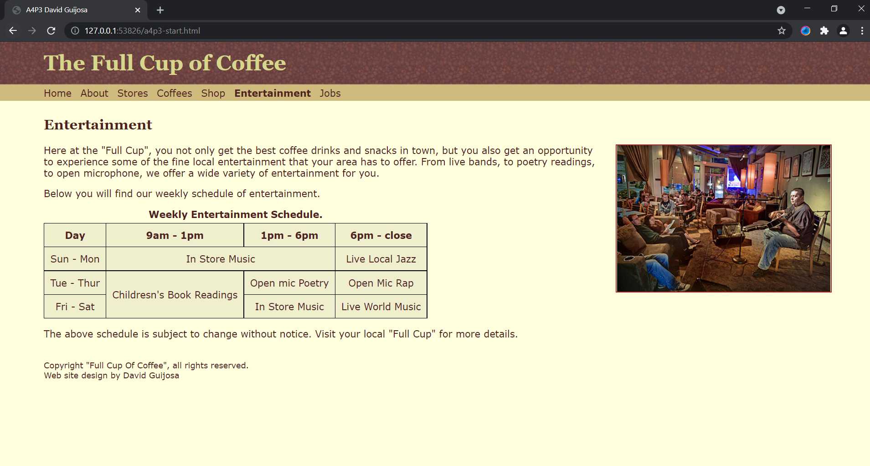

**Part 3 HTML Code: Your a4p3.html Entertainment page HTML Code:**

[Paste your a4p3.html Entertaiment page HTML Code below – Be sure to paste ALL of the HTML code for the page. No screen shots here! Use “Courier New” or another monospace font to make your code more readable. Bold the code too if that helps make it more readable. ]

**<!DOCTYPE html>**

**<html lang="en">**

**<head>**

**<meta charset="utf-8">**

**<meta name="description" content="The Full Cup of Coffee main page”**

**<title>A4P3 David Guijosa</title>**

**<link href="a4p3.css" type="text/css" rel="stylesheet">**

**</head>**

**<body>**

**<header>**

**<h1>The Full Cup of Coffee</h1>**

**<nav><a href="#" title="Home">Home</a><a href="#" title="About">About</a><a href="#" title="Stores">Stores</a><a href="#" title="Coffees">Coffees</a><a href="#" title="Shop">Shop</a><a id="thispage" href="#" title="Entertainment">Entertainment</a><a href="#" title="Jobs">Jobs</a></nav>**

**</header>**

**<h2>Entertainment</h2>**

**<p><img id="musicpic" src="musicncoffee.jpg" alt="Musical entertainment at the coffee house">Here at the "Full Cup", you not only get the best coffee drinks and snacks in town, but you also get an opportunity to experience some of the fine local entertainment that your area has to offer. From live bands, to poetry readings, to open microphone, we offer a wide variety of entertainment for you.</p>**

**<p>Below you will find our weekly schedule of entertainment.</p>**

**<!-- Place your table below -->**

**<table id="datatable">**

**<caption>Weekly Entertainment Schedule.</caption>**

**<tbody>**

**<tr>**

**<th>Day</th>**

**<th>9am - 1pm</th>**

**<th>1pm - 6pm</th>**

**<th>6pm - close</th>**

**</tr>**

**<tr>**

**<td>Sun - Mon</td>**

**<td colspan="2">In Store Music</td>**

**<td>Live Local Jazz</td>**

**</tr>**

**<tr>**

**<td>Tue - Thur</td>**

**<td rowspan="2">Childresn's Book Readings</td>**

**<td>Open mic Poetry</td>**

**<td>Open Mic Rap</td>**

**</tr>**

**<tr>**

**<td>Fri - Sat</td>**

**<td>In Store Music</td>**

**<td>Live World Music</td>**

**</tr>**

**</tbody>**

**</table>**

**<p>The above schedule is subject to change without notice. Visit your local "Full Cup" for more details.</p>**

**<footer>Copyright "Full Cup Of Coffee", all rights reserved.<br />Web site design by David Guijosa</footer>**

**</body>**

**</html>**